

CONNECTIVITY ADDENDUM
to
OptConnect Agreement

This Connectivity Addendum (this “Addendum”) outlines additional terms and conditions applicable to transactions between OptConnect Management, LLC, and its subsidiaries, including Premier Wireless Solutions, LLC, dba OptConnect-PWS (collectively “OptConnect’”), and its customer (“Customer”) who has accepted a proposal from OptConnect (the “Proposal”). This Addendum is effective on the date of Customer’s acceptance of the Proposal (the “Effective Date”), and augments the terms and conditions of that certain OptConnect Agreement located at https://optconnect.com/optconnectagreement (the “OptConnect Agreement”), as the same may be updated from time to time for all of OptConnect’s customers. By executing this Addendum, Customer elects to purchase certain wireless data and messaging services (the “Connectivity”) that are offered by OptConnect through one or more cellular network providers (the “Network Providers”). To assist Customer in the management of the Connectivity, OptConnect will provide Customer access to OptConnect’s cloud-based online SIM management portal (the “Platform,” and with the Connectivity, the “Services”). Capitalized terms not otherwise defined herein shall have the meaning set forth in the OptConnect Agreement.
NOW, THEREFORE, in consideration of the mutual covenants and promises set forth herein, the parties agree as follows:
- Nature of Relationship. This Addendum addresses multiple possible Connectivity relationships, but in each instance OptConnect is providing the Customer Connectivity that OptConnect has access to from a Network Provider. Customer’s subscription to the Connectivity will fall within one of the following two scenarios as selected in the Proposal: (a) For Customer Use -- Customer desires to purchase Connectivity for use in connecting Customer’s own wireless solutions (the “Customer Equipment”); or (b) For Resale -- Customer desires to purchase Connectivity for resale to end-user customers or to incorporate those services into Customer’s product offering for subsequent resale to Customer’s end users (“Reseller”). The specific type and quantities of Connectivity to be subscribed to by the Customer shall be identified in the Proposal and/or in one or more customer orders executed during the term of this Addendum, which specific order terms will be referred to herein as the “Customer Orders.” If the Customer is a Reseller of the Connectivity, certain additional terms and conditions of that Reseller relationship shall apply as set forth at https://optconnect.com/reseller.
- Subscription to Connectivity. Customer agrees to purchase, and OptConnect agrees to provide, the Connectivity, including the number of data service lines (the “Lines of Service”), as set forth in more detail in the Proposal and/or in one or more future Customer Orders, through a Network Provider agreed-to by the parties. Customer acknowledges that any devices it uses with the purchased Lines of Service are configured to be compatible and authorized to be used in connection with the Connectivity provided by a Network Provider through OptConnect.
- Term. This Addendum shall commence on the Effective Date and continue for the period set forth in the Proposal, and will extend automatically for one-year annual renewal terms unless either party provides written notice of non-renewal at least thirty (30) days prior to the end of the initial term or any renewal term (the “Term”). Additionally, if any term established in a Customer Order extends beyond the Term of this Addendum, this Addendum shall remain in force through the remaining term of such Customer Order. In addition to the termination rights set forth in the OptConnect Agreement, Customer may elect to terminate the OptConnect Agreement and/or a Customer Order at any time with 90 days’ notice upon payment of the termination fees set forth herein.
- Pricing. The price payable by Customer to OptConnect for the Connectivity is set forth in the Proposal and/or in one or more Customer Orders. The monthly Connectivity fee is based on data expected to be used across all of the devices covered by the Customer Orders that are on the same data plan pooled together. If Customer’s pooled data usage exceeds the plan amount in any monthly billing period, OptConnect will charge Customer an additional excess usage fee as set forth in the Customer Order. Upon the occurrence of excess data usage, Customer may elect to move to a higher data plan the following month.
- Fees Payable Upon Customer Early Termination. Upon termination by Customer of the OptConnect Agreement or a Customer Order for the Connectivity prior to the end of the term of the Line of Service, Customer agrees to promptly pay OptConnect, if applicable: (i) in full for all monthly fees due under the remaining term of the Customer Order for the Connectivity; and (ii) a "deactivation fee" equal to $25 for each Line of Service that is deactivated prior to the end of the term for the Line of Service in the Customer Order. The foregoing payment obligations of Customer shall survive the termination of the OptConnect Agreement or the applicable Customer Order. Upon termination of a Customer Order that includes prepaid Connectivity, there will be no right to a refund of those fees.
- Limitation of Liability. OPTCONNECT IS NOT RESPONSIBLE FOR AND SHALL NOT HAVE ANY LIABILITY TO CUSTOMER FOR (A) LIBEL, SLANDER, DEFAMATION OR THE INFRINGEMENT OF COPYRIGHT ARISING FROM MATERIAL OR MESSAGES TRANSMITTED OVER THE TELECOMMUNICATIONS NETWORK OF OPTCONNECT OR RECORDED ON THE EQUIPMENT OF OPTCONNECT; (B) DAMAGES ARISING OUT OF CUSTOMER'S UNAUTHORIZED ACT, DEFAULT, NEGLECT OR OMISSION IN THE USE OR OPERATION OF EQUIPMENT ACTIVATED ON THE TELECOMMUNICATIONS NETWORKS OF OPTCONNECT; (C) DAMAGES ARISING OUT OF THE TRANSMISSION OF MATERIAL OR MESSAGES OVER THE TELECOMMUNICATIONS NETWORKS UNDER OPTCONNECT ON CUSTOMER'S BEHALF, WHICH IS IN ANY WAY UNLAWFUL; OR (D) ANY ACT, OMISSION OR NEGLIGENCE OF OTHER COMPANIES OR TELECOMMUNICATIONS SYSTEMS IN RELATION TO THE PROVISION OF THE CONNECTIVITY, WHEN THE FACILITIES OF SUCH OTHER COMPANIES OR TELECOMMUNICATIONS SYSTEMS ARE USED IN ESTABLISHING CONNECTIONS TO OR FROM FACILITIES AND EQUIPMENT CONTROLLED BY CUSTOMER. OPTCONNECT SHALL NOT BE LIABLE TO CUSTOMER FOR ANY LOSS OF PROFITS OR BUSINESS OPPORTUNITIES, LOSS OF DATA OR INFORMATION, OR FOR ANY PUNITIVE, CONSEQUENTIAL, INCIDENTAL OR INDIRECT DAMAGES, ARISING OUT OF OR IN CONNECTION WITH THE PROVISION, USE OR FAILURE OF THE CONNECTIVITY OR PRODUCTS, ANY CUSTOMER EQUIPMENT OR OTHER DEVICES USED WITH THE SERVICES, OR OTHERWISE IN CONNECTION WITH THIS ADDENDUM, ANY CUSTOMER ORDER, THE OPTCONNECT AGREEMENT OR THE TRANSACTION CONTEMPLATED THEREBY, WHETHER CLAIMED IN CONTRACT, TORT OR OTHERWISE, AND EVEN IF OPTCONNECT COULD REASONABLY FORESEE OR HAS BEEN ADVISED OF THE POSSIBILITY OF SUCH DAMAGES.
- Test Ready Feature. With respect to the Connectivity, OptConnect will waive the monthly recurring charge for all lines activated with the feature Test Ready Feature (TRF/TRM/TRS) until the earliest of: (i) the device usage hits the wireless Network Provider data allowance trigger for Test Ready; (ii) the device uses the allowed number of text messages (SMS) within the Test Ready term; or 3) the applicable Date of Service Trigger for the Rest Ready Feature is reached. The day during which a device changes state from the Test Ready Feature to an activated state is when the applicable Line Term will begin for that device. The Test Ready Feature Guidelines of the following wireless Network Providers in effect as of the Effective Date are set forth in the chart below. These Guidelines are subject to change by the applicable wireless Network Provider.
Test Ready Feature per Network Provider Guidelines
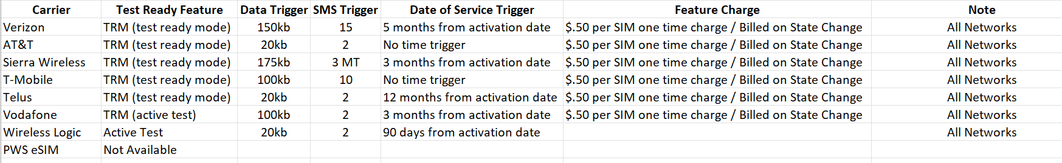
- Suspend Without Billing Policy. Customer agrees that its use of M2M (machine to machine) lines under the OptConnect Agreement must be in accordance with the then-current Suspend Without Billing policies of all applicable wireless Network Providers. The Suspend Without Billing policies of the following wireless Network Providers in effect as of the Effective Date are set forth in the chart below. The OptConnect Suspend Without Billing policy for Customer’s M2M lines is as follows: the length of time each line is suspended without billing shall extend the term of that device for a period equal to the time of suspension; if Customer leaves any line suspend without billing in excess of this policy, then OptConnect may lift the suspension without notice on the line(s) violating the policy.
Suspend without Billing Policy by Network Provider
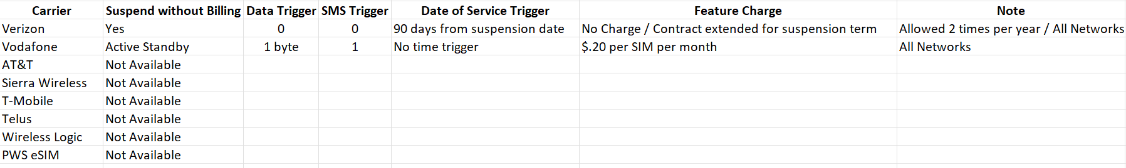
- Effectiveness; Continuity of Terms. This Addendum shall be effective on the Effective Date, and all other terms and provisions of the OptConnect Agreement and any subsequent addenda not amended hereby shall remain in full force and effect. In the event of an express conflict between the terms of this Addendum and the OptConnect Agreement, the terms of this Addendum shall control.

[END OF ADDENDUM]

